St. Francis Institute of Technology, Mumbai-400 103.

**Department of Information Technology**

A.Y. 2023-2024

Class: SE-ITA/B, Semester: IV

Subject: **UNIX LAB**

**Experiment – 7: Shell scripts -I.**

1. **Aim:** To study and implement basic Shell scripting. 

**2. Objectives:**

● To understand shell variables and shell programming.

● To develop shell scripts.

3. **Outcomes:** After study of this experiment, the student will be able to ● Develop shell scripts for simple tasks.

4. **Prerequisite:** UNIX shell.

5. **Requirements:** Personal Computer, Ubuntu OS, Text Editor, LibreOffice.

**6. Pre-Experiment Exercise:**

**Brief Theory:**

**Shell Script**

Shell is a program which interprets user commands through CLI like Terminal. The Bourne shell, bash shell and the C shell are the most used shells in Unix. Unix commands may also be executed non-interactively in the form of a Shell program or a Shell Script. The script is a series of commands that will be run together.

It can combine lengthy and repetitive sequences of commands into a single and simple script, which can be stored and executed anytime. This reduces the effort required by the end user. Typical operations performed by shell scripts include file manipulation, program execution, and printing text.

**Creating and executing a shell script**

**Steps** in creating a Shell Script:

1. **Create a file using** a **gedit** editor (or any other editor).

**2.** Name the script file with **extension .sh**

**3. Start** the script with **#! /bin/sh**

4. Write some code.

5. Save the script file as filename.sh

6. Give the shell permission to execute it.

**7.** For **executing** the script type **bash filename.sh**

**An example shell script**

The following example shows a simple shell script that lists the contents of the current directory and also shows the path of the current directory.

#!/bin/sh

ls

pwd

**7. Laboratory Exercise**

**A. Procedure**

1. Write a shell script to display a list of users currently logged in.

2. Write a shell script to perform arithmetic operations.

3. Write a shell script to copy contents of one file to another.

**B. Result/Program code Screenshots**

**8. Post-Experiments Exercise**

**A. Extended Theory:** 

Nil

**B. Questions:**

1. Write a shell script to check whether a number is even or odd.

2. When to use shell scripts?

3. Where is the bash program located on your system?

4. How to find the current shell which you are using in UNIX?

**C. Conclusion:**

1. Write what was performed in the experiment.

2. Mention few applications of what was studied.

3. Write the significance of the topic studied in the experiment.

**D. References:**

1. Yashwant Kanetkar, UNIX Shell Programming, BPB Publications. 2. Sumitabha Das, UNIX Concepts and Applications, 3rd Ed., Tata McGraw Hill. 3. <https://www.guru99.com/introduction-to-shell-scripting.html>.

* Example of Shell Script

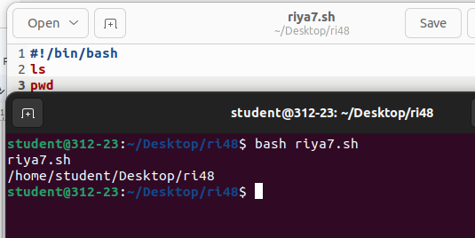

* Write a shell script to display a list of users currently logged in.

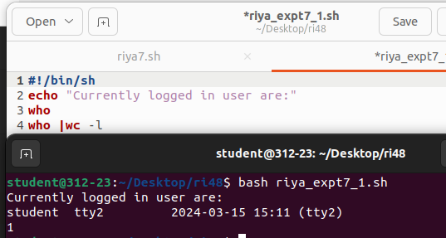

* Write a shell script to perform arithmetic operations.

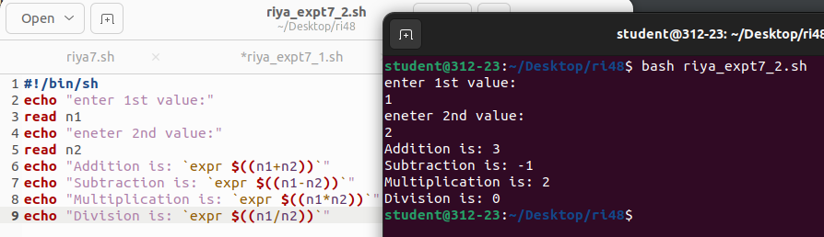

* Write a shell script to copy contents of one file to another.

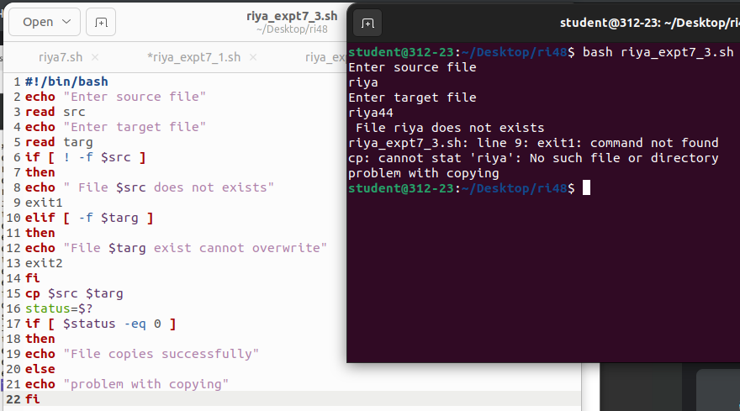

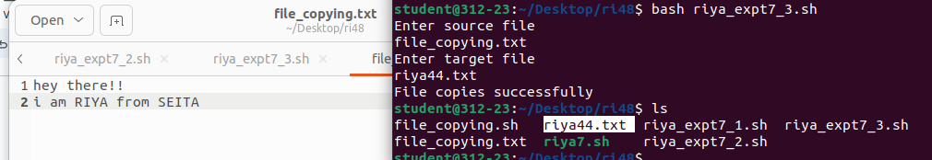

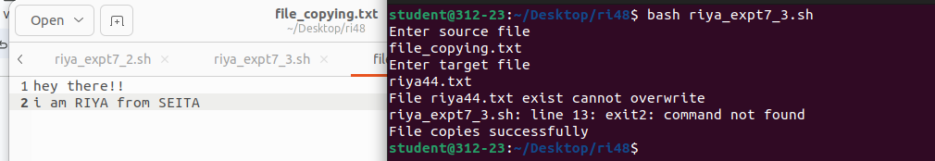

* Write a shell script to check whether a number is even or odd

